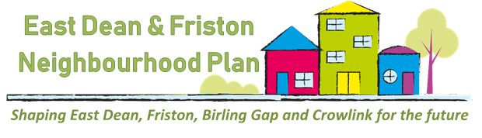

We need your input. Would you like to have a say in what the Parish will look like in the future? Then please read below:

Neighbourhood Plan – so what is it?
Neighbourhood Plans provide communities the opportunity to play a stronger role in shaping the areas in which they live and work and in supporting new development proposals. Neighbourhood Plans are different to the Parish and Village Design Statements. They sit alongside the Local Plan prepared by the local planning authority, in our case the South Downs National Park Authority, and as another statutory plan have real force.
One of the most vital aspects of a Neighbourhood Plan is that it takes into account the views of ALL in the community. During the next few months we will be asking about what’s important to you.
Neighbourhood Plans are about much more than future housing provision, they also encompass protection and enhancement of our natural environment, green spaces, heritage assets, community facilities, business and local economy.
What are we doing?
On 16th October 2018, East Dean & Friston Parish Council resolved to set-up a Neighbourhood Plan Steering Group. We asked for volunteers from the community to step forward and volunteer their time to help us start the process of devising a Neighbourhood Plan; the group met for the first time on 19th February 2019.
Have your say!
If you missed our presentation at the Annual Village Meeting you will still have plenty of chances to meet members of the Neighbourhood Plan Steering Group and tell us your views on the strengths, weaknesses, opportunities and challenges presented by living and working in our parish. We hope to see you at our first community event at the Village Fete on the 20th July.
Your feedback is vital because it will be used to help formulate a vision for our parish and a series of objectives for the Neighbourhood Plan. Please do take the time to tell us what you think.
If you have any questions or suggestions about the Neighbourhood Plan, you can email us at admin@edfparishcouncil.org.uk, call us on 01323 422029 or drop us a line using the Village Hall post box or the one provided in the Barn Stores.
For the latest updates and more information about Neighbourhood Plans please visit our website http://www.edfparishcouncil.org.uk/Neighbourhood_Plan_24625.aspx

(Neighbourhood Plan Steering Group June 2019)

Your Parish Councillors:

Tim Bryant
Nigel Day
Lesley Durso
Kevin Godden
Phillip Hill
Mike Keller (Chair)
Paul Seeley (Vice Chair)
Joyce Walker
Beatrice Wheatley

Your Neighbourhood Plan Steering Group Members:

Cllr Tim Bryant (Chair)
Sean Carmody
Wendy Carmody
Joan Colin
Megan Davis
Cllr Lesley d’Urso (Vice Chair)
Bernie Ewer
Vanessa Farmer
Cllr Kevin Godden
Cllr Mike Keller
Annemieke Milks
Sue Pettifor
Bob Salmon
Cllr Paul Seeley
Jane Tatum
Cathy Vine
Diane Williamson
Peter Williamson

