? ?
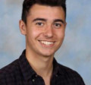?
Who’s missing?
Is it You?
You may be just the person our village needs.

Would you like to - Represent the views of local people - Bring fresh ideas about local services - Help keep our village a good place to live in.
On 6th May there will be the opportunity to elect three Parish Councillors to fill the current vacancies. No prior experience is needed, just a desire to help our community.
If you are interested please contact the Parish Clerk on 01323 811870 or clerk@edfparishcouncil.org.uk

