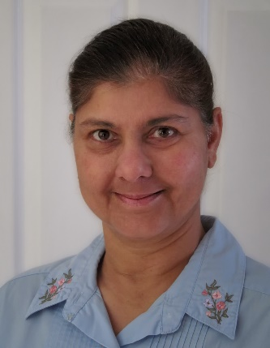
Debbie Picknell – Admin Assistant

A Sussex girl I started life in Brighton and enjoyed a steady job working for the Civil Service for 28 years. Here I met my husband Nigel and have been happily married since 1985.
In 1996 we moved to the tranquillity of East Dean where walking has been a great past-time.
Entwined with a zest for adventure and new experiences I enjoy travel, photography, video editing, wildlife spotting and dancing!

